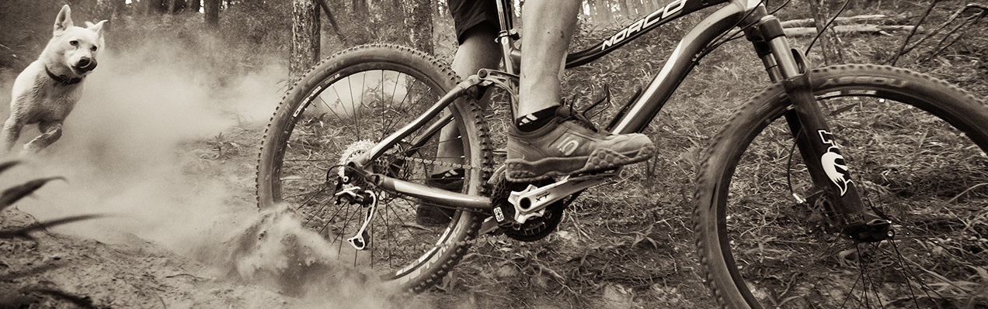

Mountain Bike Ride

Clothing
1 Waterproof jacket*
1 Pair Shorts (preferably non-cotton)
1 Shirt (preferably non-cotton)
1 Pair athletic shoes or bike shoes
1 Pair socks
Gloves

Food
Capacity to carry 2L of water
Trail Snacks (if you so desire)

Other
Mountain Bike**
Bike Helmet**
Small pack to carry water
Personal Medications

Optional
Cushioned Bike Shorts
Water Bladder
Lip protection
Sun block
Personal First Aid Kit
Sunglasses
Camera

*Necessary dependent upon weather conditions.
** Available to rent from Outdoor Rec. upon request.

Activities
We will be biking around…

Questions/Contact
Brad Pointer: bpointer@whitworth.edu
Jacob Schmidt: jschmidt16@my.whitworth.edu

Refund Policy
Cancellations made less than two weeks (14 days) prior to the event are not refundable.
• There is a $5.00 fee for all cancellations and transfers.
• Should Whitworth Outdoor Rec cancel a trip or a class, we will issue a credit or full refund.
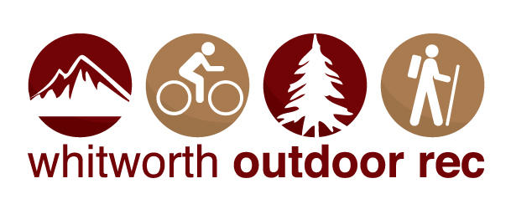
Reasons may include severe weather, road conditions, instructor illness, and participant numbers.

