LOCATION: __________________________________________________
PRE-TRIP MEETING: ______________ @ ___ PM in the Outdoor Rec Office → U-Rec
TRIP: Date of Trip: __________________ Meeting Place: Outdoor Rec Office → U-Rec
Meeting Time: _________ Approx. Finish Time: _________

CLIMBING DAY TRIP

Clothing
- 1 Waterproof jacket*
- 1 Waterproof pants*
- 1 Pair Outdoor Pants (preferably non-cotton)
- 1 Shirt (preferably non-cotton)
- 1 Insulated Layer (top)
- 1 Pair Climbing Shoes**

Food
- Your own lunch for the day
- Ex: Sandwich, fruit, etc.
- 2L of water
- Trail Snacks (if you so desire)

Other
- Daypack to carry lunch & water
- Climbing Harness**
- Belay Device**
- Personal Medications

Optional
- Water Bladder
- Climbing Tape
- Lip protection
- Sun block
- Personal First Aid Kit
- Sunglasses
- Camera
*Necessary dependent upon weather conditions.
**Available to borrow from outdoor rec free of charge upon request.

Activities

We will be climbing single-pitch routes. Sport, and toprope climbing will all be available. Shoes and harnesses will be available upon request prior to the trip.
It may be possible for experienced trad and sport leaders to bring their own gear at the discretion of the trip leaders.

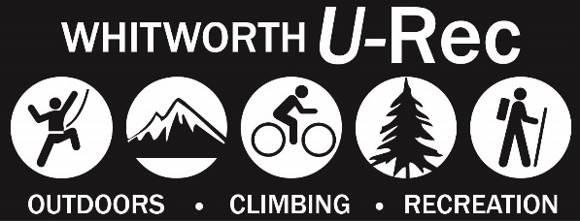
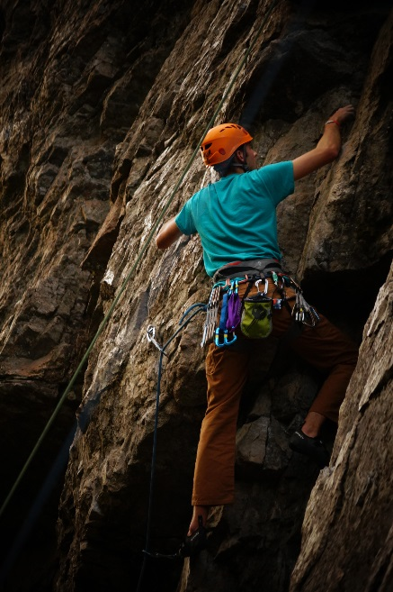

Check out www.whitworthoutdoors.com for more information
Like the Whitworth Outdoor Rec Facebook page to stay updated about upcoming trip opportunities!

ONLINE WAIVER INSTRUCTIONS
Go to
www.whitworth.edu/urec
and follow the link that says “Waivers” on the left side of the page in the grey box. Next, click on "Outdoor Recreation Waiver" and you will be prompted to enter your login credentials. Please be sure to fill out the waiver BEFORE the trip.

Questions/Contact
whitworthoutdoorrec@gmail.com

Refund Policy
Cancellations made less than two weeks (14 days) prior to the event are not refundable.
• There is a $5.00 fee for all cancellations and transfers.
• Should Whitworth Outdoor Rec cancel a trip or a class, we will issue a credit or full refund.
Reasons may include severe weather, road conditions, instructor illness, and lack of participant numbers.

